Victoria Hancock Presents

Jeu Jeu la Foille’s Testy Manifesto

A strange, poetic, and acerbically silly take on intimate partner violence and the revolution we need
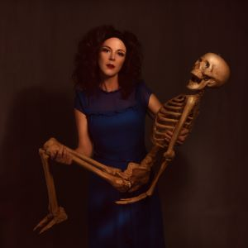
“We all know that to be a true infiltrator into patriarchy, one must find costumes, disguises and secret doors with which to enter enemy territory, in order to dismantle it.” Susan L. Abert

Enchantress weaves words of inner resilience, recovery and revolution in a striking visual anthology. Combining linguistic acrobatics with evocative images, puppetry, and sensory experiences to delve deep into the mechanisms of intimate partner violence.

This 'difficult' second album is the follow-up to 'Jeu Jeu la Foille's Frontal Lobotomy', which dealt with experimental brain surgery, while heavily under the influence of Tom Waits.

Jeu Jeu la Foille is a poet, clown and burlesque maverick who likes beautiful melodies telling her terrible things.

‘Accesible yet fantastical’ The Scotsman
‘An utterly compelling artist’ Fringe Guru
‘Joyfully bizarre’ Theatre Bubble
‘This potent mix of cleverness and hotness should be illegal’ Barelesque
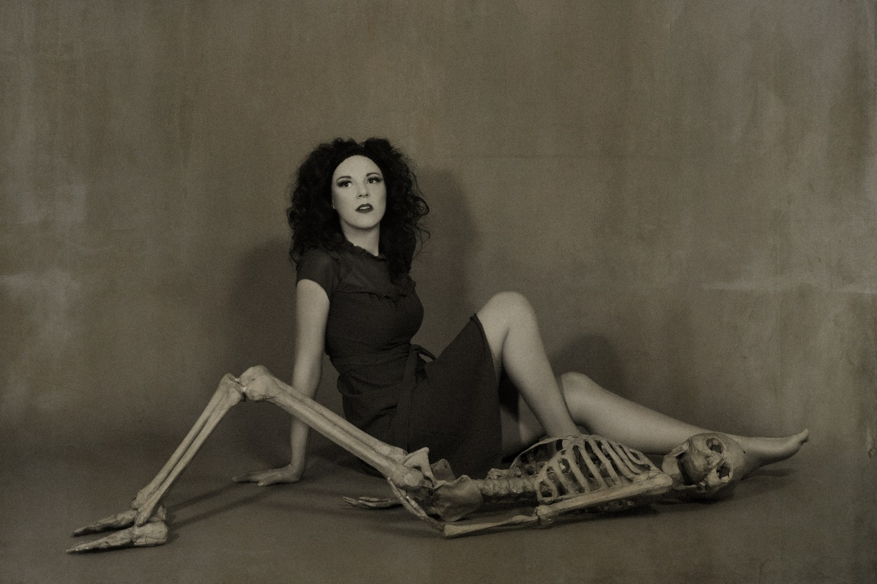
Show Information
50 minutes in length
10 minutes set up and clear up time
Space required: Minimum 3x3 metres
Set: Two wooden folding chairs and a hatstand. No set required from venue.
Technical: 8 sound cues from GoButton. Lighting plan available on request.
Age Restriction and warnings: 14+ Mild swearing, adult themes. Perfume is sprayed into the air at one point during the show.
Personnel: 1 performer
See the trailer here: https://youtu.be/xKVwySJ9Wps?si=jU5smlxOUNw5mzq0
Full filmed performance available on request
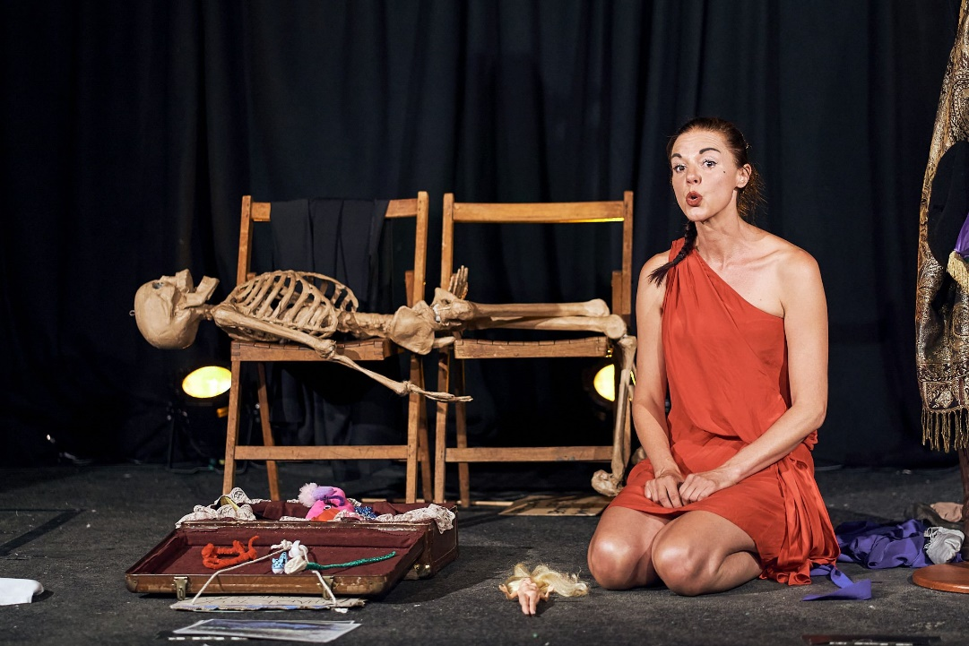
Written Audience Feedback from ‘Propel’ at MAST August 2023
If you were describing this piece to someone who hadn’t seen it, what would you say?
Feminist clowning and punchy spoken word. Engaging performer.
Nicely performed. Good poetry. Not sure what’s going on.
It’s a piece about the female condition. Thank you. I really ‘enjoyed’ it.
Cutting deep.
Spoken word. Creative. Multi-rolling. Emotive.
A timeline of a feminist.
An illustration of how women are doomed in an amusing and non-didactic way.
A little bit bonkers and a bit of a mish-mash of styles and ideas and writing. Leftfield 😊
Very interesting. Beautifully played. Disjointed.
A miscellany of opinion and monologues seen through the performers eyes. Fringey.
That it’s a piece about the human experience as a woman with comedy and refreshing links to the past.
Be open minded. One woman show.
A feminist manifesto in French-lish.
Off the wall fringe show with feminist info.
Quirky one woman multirole feminism and revolution show (Definitely worth seeing!)
Different language styles. Varied female persona.
A slightly disorientating but thought provoking monologue that had me entertained throughout. France also. It was quite brilliant.
Gosh! No idea. Very entertaining, wonderfully performed, but have no idea how to describe it…Be ready for surprises.
An intriguing, absorbing piece of performance. A one woman show about her abusive relationship.
Electric and engaging performance piece with serious issues but a sense of fun. Slightly campy (in a good way) Beautiful writing.
Beckett meets Avenue Q meets The Good Fight.
An exciting incite on enacting and continuing revolution.
Clever use of language, playing with words. Theme of age-long struggles – political and very much the personal.
You have to see this!! I don’t really know how to describe it, but it’ll make you scratch your head, fill your soul with imagery and thoughts, rock and roll you, smash you up and warm your cockles and ok I’ll stop now – it was very poignant, but also made me feel RAAA. Powerful.
A creative, funny, considered meditation on femininity.
Powerful, impactful and really thought out. Felt like you were transformed into a different world with the poetic language. Really impressive!
A series of ideas being performed beautifully to make you think, think and think some more!
Powerful and poetic.
Past Performances
Thursday 28th November 2019, Cabaret Playroom, The Albany Theatre, London
Friday 28th February 2020, Moving Voices, The Art House, Southampton
​Tuesday 3rd November 2020, Poetry Platform, The Railway Inn, Winchester
Friday 26th March 2021, Moving Voices (Online)
Saturday 24th July 2021, Guildford Fringe Festival, The Back Room of the Star Inn, Guildford
​Monday 20th September 2021, October Books, Southampton
Saturday 30th July 2022, The Nest, Ventnor Fringe, Isle of Wight
Saturday 6th and Sunday 7th August 2022, Camden Fringe, The Hen and Chicken's Theatre, London
Thursday 19th January 2023, Words at Whiskey, Whiskey Blue, Southampton
Saturday 26th August, Propel Scratch Night, MAST Mayflower Studios, Southampton
Thursday 19th October, Faversham Fringe, The Guildhall, Faversham
Upcoming: May 4th and 19th, Rotunda Theatre, Brighton

About Victoria Hancock aka Jeu Jeu la Foille
Victoria Hancock is a poet, clown and semi-retired burlesque maverick, who trained in mime, acrobatics and Lecoq-based physical theatre at the London International School of Performing Arts and Arthaus Berlin, when she was already a bit too old to run away with the circus.
A popular and well established regular on the UK cabaret scene as Jeu Jeu la Foille from 2010 to 2019; she performed narrative burlesque vignettes, and was a co-creator and costumier with surrealist clown troupe ‘The Mist – We Are Not Cakes.’
In 2016 Victoria created her first solo show ‘Jeu Jeu la Foille’s Frontal Lobotomy’ which dealt with experimental brain surgery, while heavily under the influence of Tom Waits. She began to develop a unique style of solo, anthology performance art; combining spoken word, puppetry, music and costuming. The show toured with Arts Council funding in 2017, and was nominated for a Buxton Fringe Award for Best New Writing.
Jeu Jeu la Foille likes beautiful melodies telling her terrible things, and after surviving an abusive relationship in 2018, she went on to write and perform ‘Jeu Jeu la Foille’s Testy Manifesto’, which dealt with intimate partner violence and the French Revolution. Oddly enough, the show turned out to be quite funny. Victoria continues to campaign for an end to violence against women and girls.
As a writer, she doesn’t retreat from taboo subjects, and has two poet voices; angry and triumphant or sad and whimsical. A true DIY artist, Victoria’s performances have been described and compelling and mesmerising, and she is currently wrestling with a third solo show; working title – Jeu Jeu la Foille’s Pithy Obituary.
Besides being a theatre artist, Victoria also works as a Wardrobe Supervisor, Funeral Celebrant and Teacher of Acting. She will also be appearing in a musical written by Grant Sharkey this year.
www.jeujeulafoille.com
Read my blog: Jeu Jeu la Foille - Nowhere to go but everywhere
Instagram @jeujeulafoille

