SJ Associates
Jeu Jeu la Foille: Frontal Lobotomy
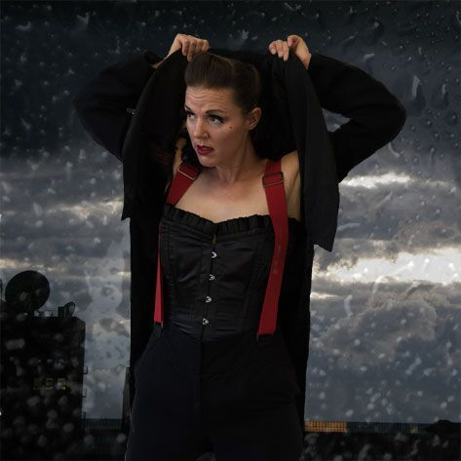
Visual Theatre and Poetry, spun together with a Tom Waits inspired soundtrack and a smattering of weird science
Show Description
Bold, witty, and surreal, burlesque maverick Jeu Jeu la Foille fuses original beat poetry with the tormented lullabies of Tom Waits; punctuated with scientific accounts of perhaps the biggest error of judgment in medical history – the transorbital lobotomy. Dreamlike, passionate, and sometimes ridiculous; a dance through the woozy mythology, skewed narrative and embellished truths in the melancholic, irreverent world of Waits. Raising questions on differing attitudes towards mental illness, the various coping mechanisms, and with a unique blend of form and style -expect gruff puppetry, beatnik burlesque, spoken word, and a junkyard orchestra of musical reprobates.
Press from the Edinburgh Fringe debut run 2016 at the Laughing Horse Free Festival
The Upcoming
“Featured in The Ten Most Highly Anticipated Shows of the Fringe: Burlesque babe Jeu Jeu la Foille interestingly commingles original spoken word with the tantalising musical work of Tom Waits to create an intoxicating, sultry spectacle.”
FringeReview
“There’s a delicate cheekiness in the air. It’s a mix of disarming innocence, a coy smile and a theatrical wink which keeps you constantly intrigued… It immediately tickles your funny bone, letting you sit back and savour the formality being traduced…. Tying together the themes is a running soundtrack/soundscape of Tom Waits, either playing live (archly and hilariously mimed by Jeu Jeu in a hastily donned slouch hat – the arrival of her band is a treat – or Waits appearing as a puppet, manipulated by her, smoking a cigarette…”
Three Weeks
“Creative and engaging… La Foille clowns her way through burlesque and passionate prose – surely this is how every poetic anthology wishes it could be presented?”
The Scotsman
“Clever, controlled, accessible yet fantastical – and the whole thing is held together by La Foille’s relaxed and assured stage presence.”
Derek Award nominee 2016 for ‘Best of the Free Fringe’
Artist Description
Creator and performer Victoria Hancock is trained in physical theatre, voice, puppetry and clowning (LISPA, LAMDA, Rambert and Queen Mary College, UofL). A popular and well-established regular on the UK cabaret scene, and known for her comic and narrative burlesque – Frontal Lobotomy is her debut solo show, with a deliberate lean toward poetic writing and vocal dexterity.
Show Information
Length
50 minutes with no interval
Set up time for full length show: 10-15 minutes
Clear up time for full length show: 10 minutes
Excerpts also performed: 5-10 minutes, with minimal set up/clear up time
Technical
Solo performance, small-scale touring theatre: Space required is minimum of 3 metres wide and 2 metres deep.
Set required: 1 chair.
Lighting: 1 mid-show black out required, practical (desk light) onstage, so an electricity source and extension lead required. Can be modified for different venues.
Sound: 7 cues, tech script provided. Sound can also be operated by the performer if the speaker connection allows the ipad to be close to the performance space. I only use a microphone for excerpt performances, in very large or noisy venues.
Contact/Further Information
www.jeujeulafoille.com
www.jeujeulafoille.com/nowhere-to-go-but-everywhere
@jeujeulafoille
www.facebook.com/lafoille/
vickyhancock@hotmail.com – PLEASE EMAIL FOR A FULL PRESS PACK AND IMAGES

